WEEK 1
DATA STRUCTURES AND ALGORITHMS
Exercise 2: E-commerce Platform Search Function
Main.java
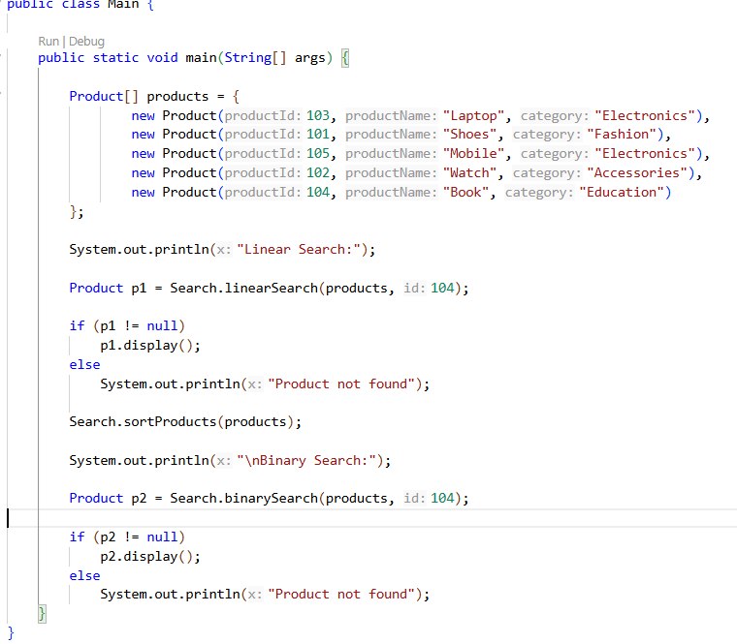
Product.java
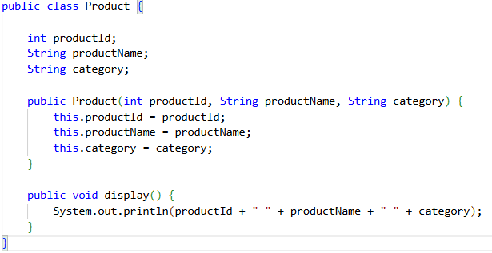

Search.java
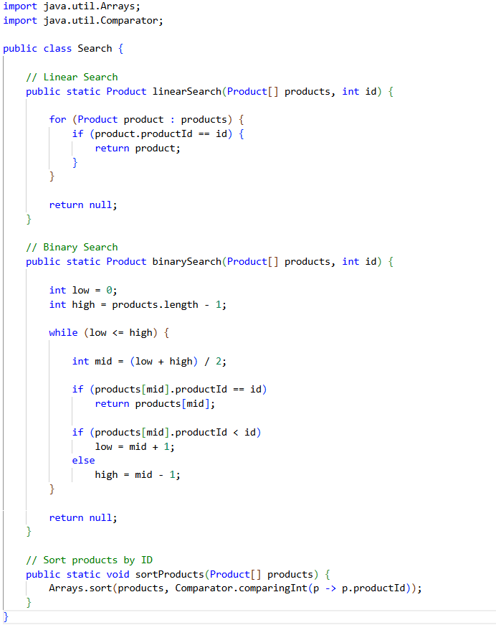
Output
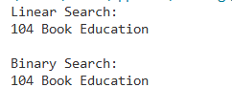
Exercise 7: Financial Forecasting
Main.java
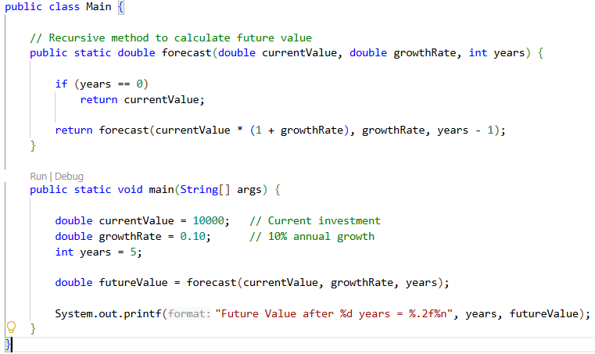
Output

